

MET/37 Vol II (539-61)

SIERRA LEONE GOVERNMENT

Meteorological Department
F18 Charlotte Street
Freetown
1St October, 2015

The Secretary- General
UNFCCC Secretariat
Martin-Luther-King Strasse 8
53175, Bonn
Germany

Dear Sir,
Submission of Sierra Leone’s Intended Nationally Determined Contribution (INDC) Document to the UNFCCC Secretariat
I write with respect to the above subject matter and to submit the final version of Sierra Leone’s INDC Document as attached in meeting our obligation for the coming Conference of the Parties (COP21) in Paris, France for your kind attention and necessary action.
Please acknowledge receipt.
Your cooperation is highly solicited.
Yours faithfully
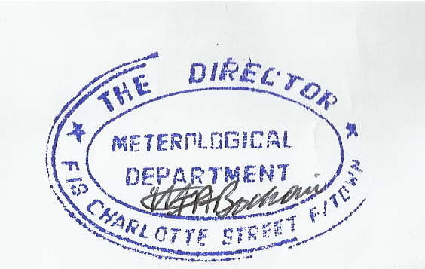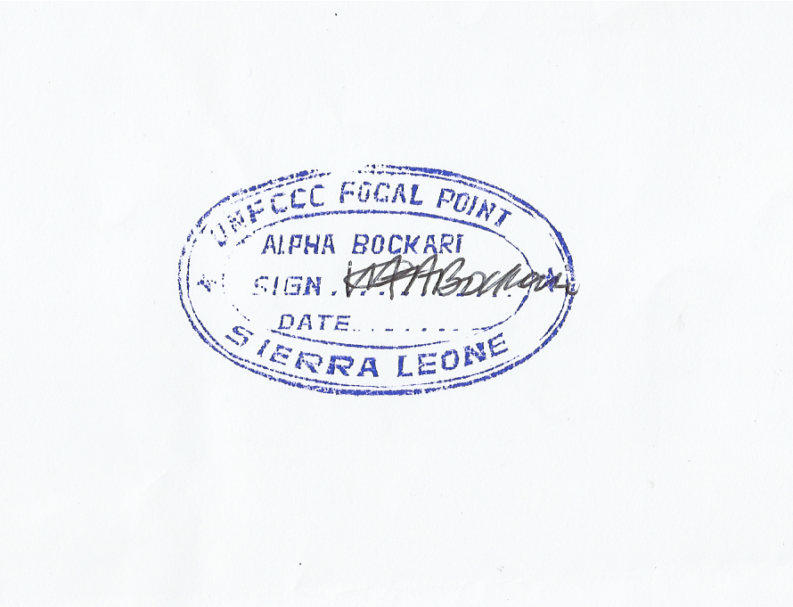

Alpha Bockari
Director/UNFCCC National Focal Point for Sierra Leone

Copy:
The Hon. Minister, Ministry of Transport and Aviation
The Hon. Deputy Minister, Ministry of Transport and Aviation
The Permanent Secretary, Ministry of Transport and Aviation
The Executive Chairperson, EPA-SL
Prof Strasser-King, SPU, State House, Freetown

